**Spatio-temporal analysis of mobility pattern during COVID-19 in NYC**

**Xiaoyi Wu**

**Introduction**

Since the World Health Organization declared the novel coronavirus (COVID-19) outbreak a global pandemic on 11th March in 2020, the disease has influenced every part of daily life and caused more than six million deaths globally (Johns Hopkins Coronavirus Resource Center, 2022). Mobility pattern tracks human movement behavior, which is critical to understand, evaluate and predict the pandemic transmission. Commuting and large scale gathering aggravate pandemic transmission, while the onset of COVID-19 prevents social activity and lower travel behavior. Thus, many non-pharmacological policies such as quarantines, travel restriction, social distancing has been implemented by governments to prevent the spread of COVID-19.

Since the first confirmed case on March 1st, New York City has become the pandemic epicenter(Cordes & Castro, 2020) as the most populous city in the United States with 8.8 million people distributed over 300.46 square miles (U.S Census Bureau, 2020) . Under the setting of New Year’s Eve and Omicron variant, NYC experienced the peak of COVID-19 with 60671 confirmed and probable cases on 3th January 2022. Understanding the spatio-temporal changes of human mobility and analyzing the disparities in mobility during that time helps the government to properly response to public health emergencies.

**Literature Review**

Existing studies typically examine the spatial distribution of mobility changes during a specific time. However, most work don’t take the temporal changing pattern into consideration from a long perspective and compare the spatial pattern before COVID-19. In addition, analyzing the changes with contextual factors such as race and income is also very important for the policy makers to reallocate resources efficiently and effectively. Thus, a more comprehensive study of mobility pattern change with social equity analysis over time is needed.

**Motivation**

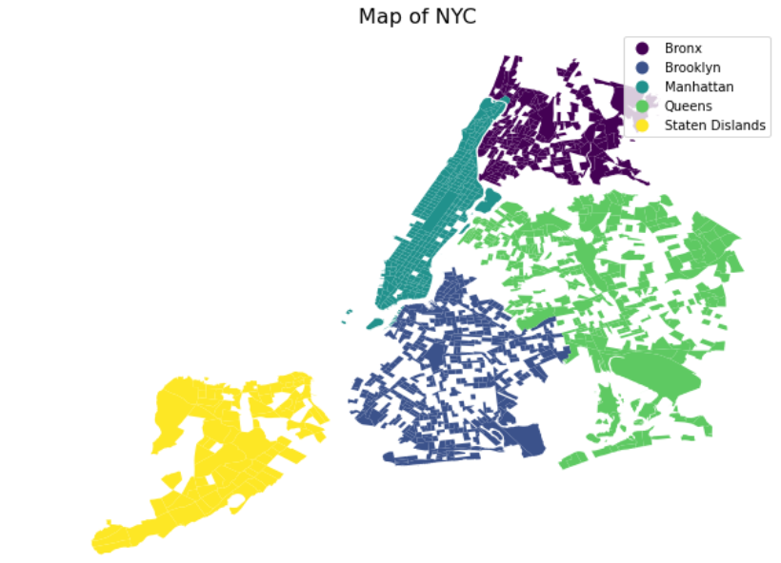

This study aimed to study the spatio-temporal changes of people’s mobility before and during the peak of COVID-19 in NYC. In particular, this study uses the smart-device pattern data from December to January in 2019-2020, 2020-2021, 2021-2022 from SafeGraph. In addition, this study analyzes the shifting mobility pattern in different race and income contexts to discuss the social equity issues and make policy implications of travel restrictions for the local government.

This study focuses on the following questions:

1. What are the most popular spots for people during COVID-19? How long people have stayed there? Where are they come from?
2. What are the spatio-temporal changes of mobility pattern during COVID-19?
3. How do the socio-economic factors influence people’s travel activities in different contexts?

**Data**

The study used pattern dataset and core places dataset from SafeGraph to collect mobility information. These datasets aggregate anonymized smart-device GPS data based on census block group level from third-party applications. [Core Places](https://docs.safegraph.com/docs/core-places) dataset includes 71468 Points of Interests (POIs) with their location name, category, and brand association in NYC. The [Patterns](https://docs.safegraph.com/docs/monthly-patterns) dataset records information about the location and frequency and people visit a specific POI, how long they stay there, where they came from, where else they go (SafeGraph, 2022).

Besides this, this studies wrangled the American Community Survey (ACS) 2015-2019 5-year data to get the socio-economic information such as race and income based on tract level associated with the mobility pattern analysis.

In addition, we collected the geographic 2020 Census Tracts (clipped to shoreline) data from the US Census Bureau's TIGER data products as the NYC based map.

**Methods**

Firstly, we collected weekly mobility pattern dataset and place dataset from 23th December 2019 to 13th January 2020, 21th December 2020 to 11th January 2021 and 20th December 2021 to 10th January 2022 and aggravate the data based on tract level. Then, the mobility index was constructed to represent the density of travel behavior on tract level. Combined with ACS 5-year data from U.S Census Bureau, we analyzed the mobility index in high-and low- income areas as well in white-majority and non-white majority areas.

**Analysis**

**The demographic of NYC is …**

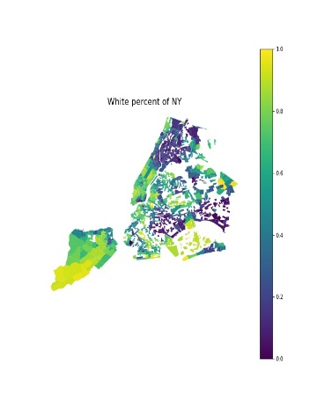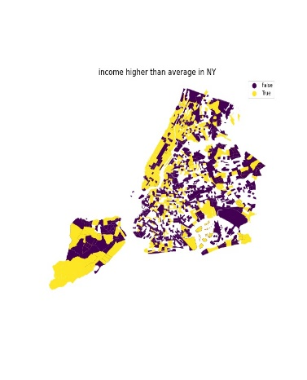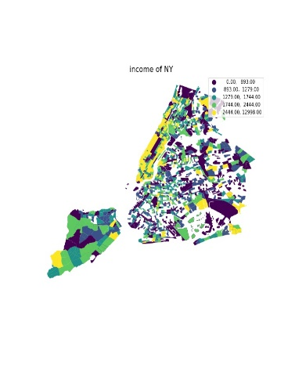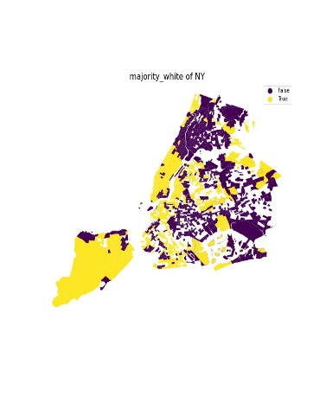

Firstly, we analyzed people’s visit counts to public places in different years and found people increased their visits to accommodation and transportation most significantly.

From 2020 to 2021, visit to transportation places has increased by 181%, while that of accommodation decreased by 12%. From 2019 to 2020, visits to transportation increased by 69%, while that of accommodation increased by 128%.

Table 1 Change of visit count, visitor number and dwell time in 2019, 2020 to 2022

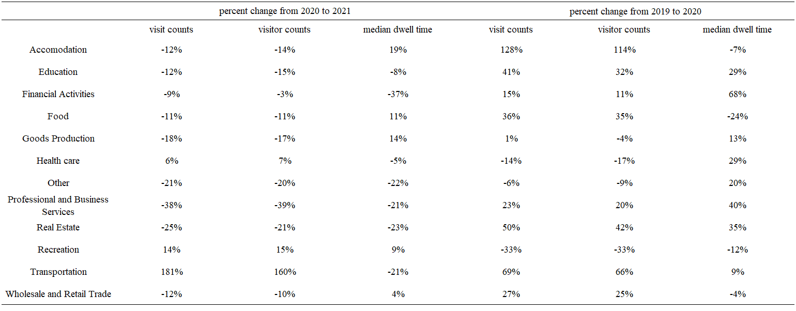

According to the choropleth maps of people’s visiting count and dwell time, we found clustering pattern of high volume of visitors and visit count in mid and lower Manhattan, south and east Staten Island and areas around John F. Kennedy (JFK) International Airport.

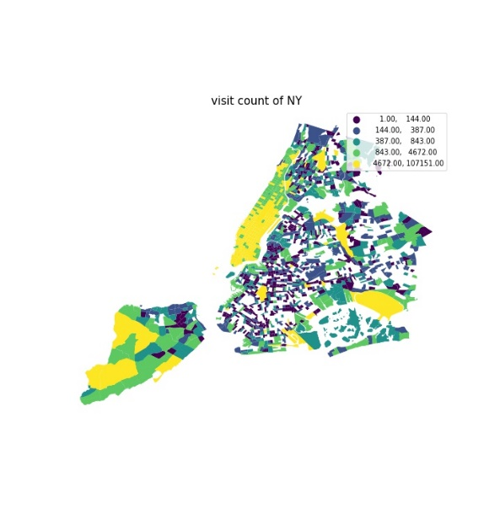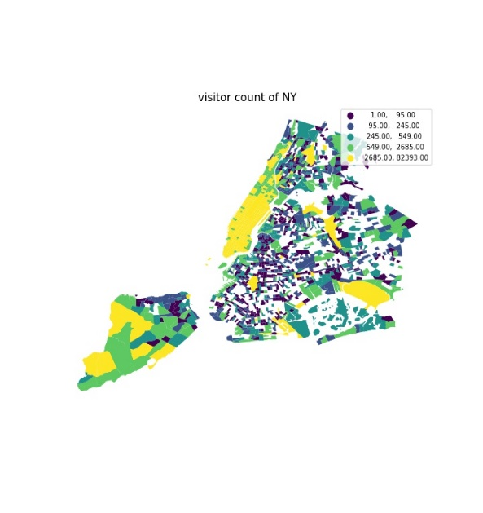

Combined with the ACS demographic data, tracts in Staten Island and Manhattan with higher volume of visiting counts and visitor number tend to have higher income and white majority ratio than that of low visiting counts and visitor number. We think living expense in such places tend to be higher than other places, since the mid town and the lower town in Manhattan can provide more convenient services as the center of economy of the City. While the environment in Staten Island is more resident with beautiful nature landscape.

However, the tracts around JFK international airport with higher volume of visiting counts and visitor number tend to have less income and white majority ratio, since it is located at the suburb area and can’t provide convenient services.

As for the POI distribution, from the 2019 to 2020, POI counts in transportation has increased by 50 which is 40%; from 2021 to 2022, POI counts in transportation has decreased by 18 which is 30%. While POI counts in accommodation remain almost constant in different years.

Table 2 POI counts in different years

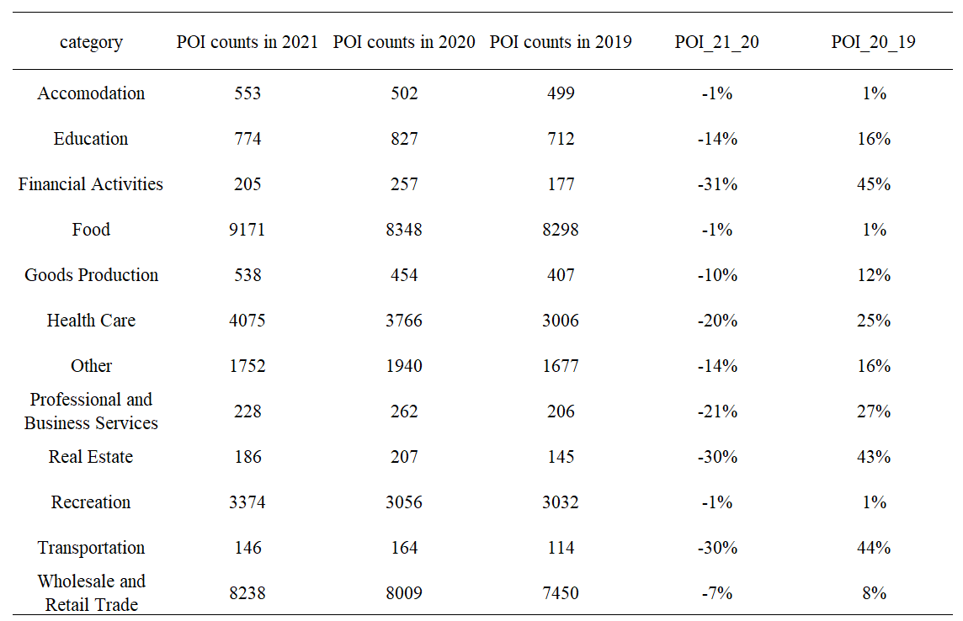

Transportations

From 2019 to 2020, people’s visits to John F Kennedy International Airport Terminal in Queen Borough increased from 1205 to 7180, which is 495.9%; at the same time, people’s visits to LaGuardia Airport increased from 23659 to 100413, which is 324.4%.

From 2020 to 2021, people’s visits to John F Kennedy International Airport Terminal in Queen Borough increased from 7180 to 84944, which is 1083.1%; however, people’s visits to LaGuardia Airport decreased from 100413to 71140, which is 29.2%.

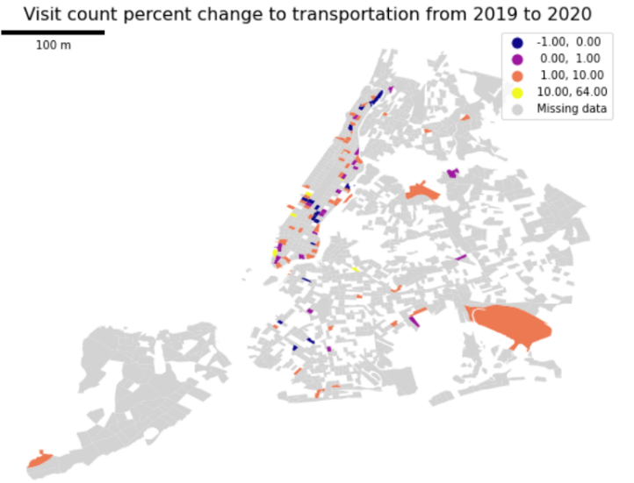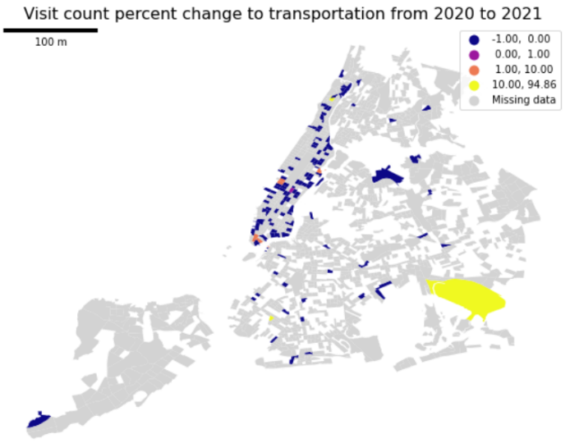

This study analyzes percent changes of visit count and median dwell time to different categories in Transportation.

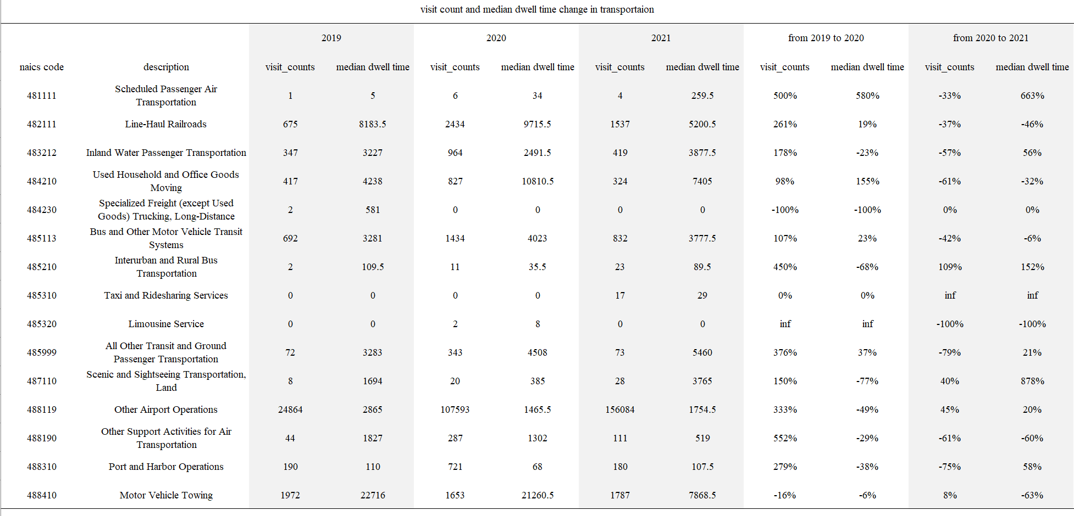

As for the visit count, from 2019 to 2020, people decreased activities in freight delivery and motor vehicle towing, however, they increased visits to air transportation, harbor port, airport, ground transit and harbor port twice. From 2020 to 2021, usage of interurban bus transportation and rural bus transportation has increased by over 109% and sightseeing transportation activities increased by 40%, while visits to other categories decrease in general.

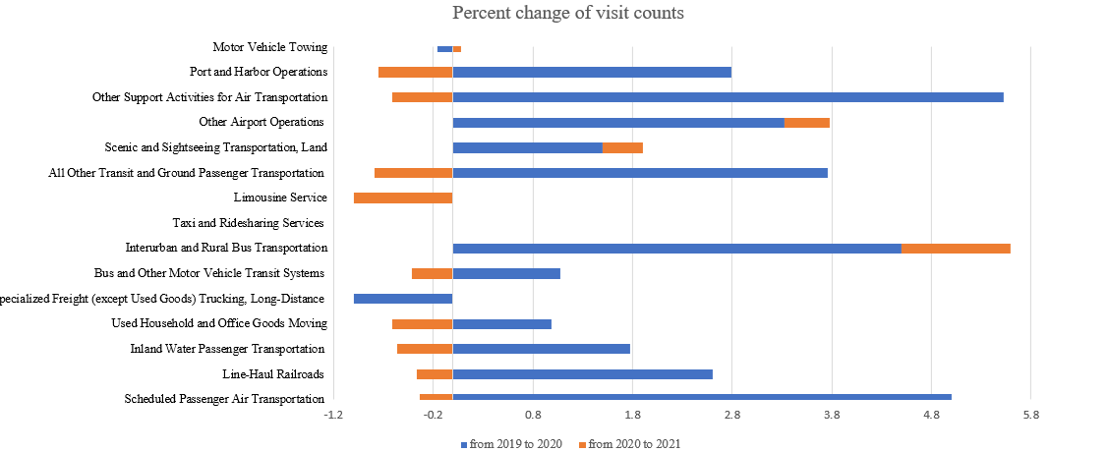

As for the dwell time, from 2019 to 2020, people increased their dwell time in airport most by 580%, and time in goods moving place by 155%. Dwell time in ground transit is increased slightly by 37%. As for the dwell time in trucking and scenic transportation have decreased most by 100% and 77% accordingly. From 2020 to 2021, people increased their dwell time in scenic and sighting seeing transportation and airport most by 877.7% and 633.3% accordingly. Time in interurban and rural bus transportation also increased by 152.1%. However, time spent at limousine services has decreased by 100%.

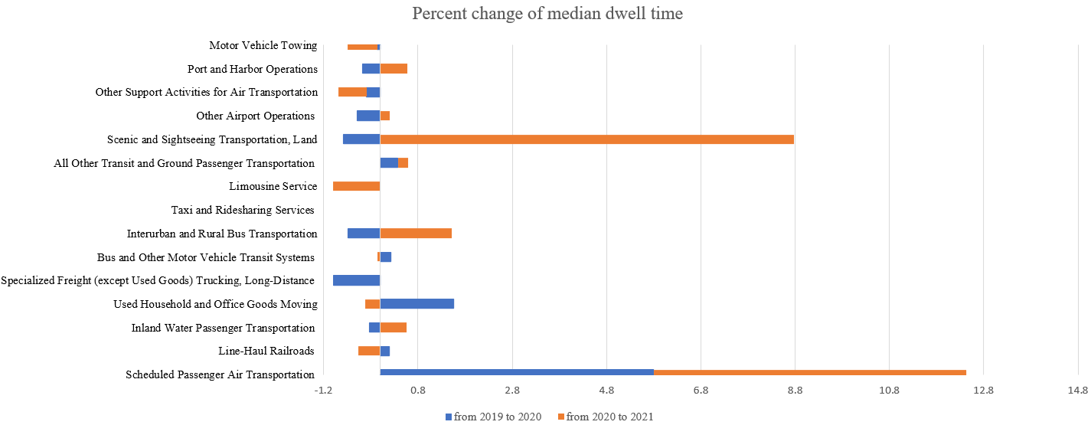

However, further analysis about correlation between demographic factors and mobility pattern and spatial autocorrelation need to be implemented.

**Literature**

[1] Cordes, J., & Castro, M. C. (2020). Spatial analysis of COVID-19 clusters and contextual factors in New York City. Spatial and Spatio-temporal Epidemiology, 34, 100355.

[2] <https://coronavirus.jhu.edu/map.html>

[3] https://www1.nyc.gov/site/planning/data-maps/open-data/census-download-metadata.page